**Session report 02/05/2023:**

*LABAUVIE – RAFFAELLI EVA*

*ROB3*

I got back my Wheel from printing :

The goal is to print the last pieces and bring them together.

I made the shovels bigger :

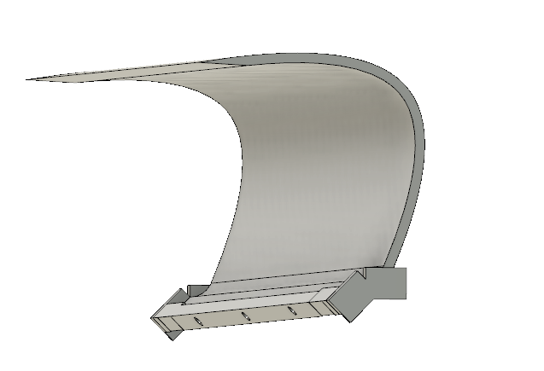

Now I need to print them, and the pieces that will make the conveyer spin.

Next, I started to export in DXF format the sketches of the box to cut them with the laser device of the Fablab.

Then I used InkScapes :

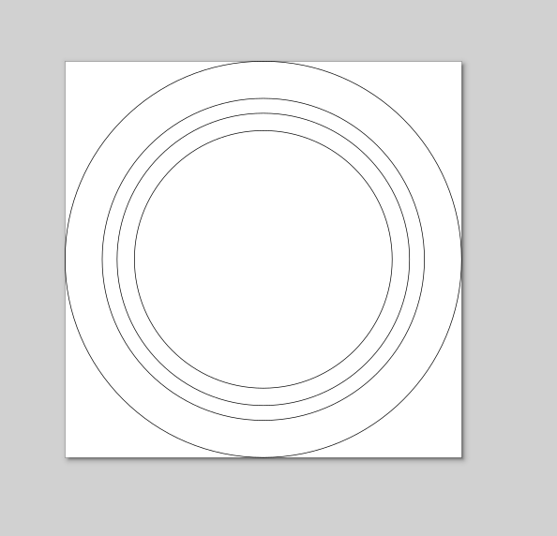

Then I had to put each piece together and cropping the buckets to they fit perfectly :

